**1 FTL**

http://freemarker.org/

**2. Eclipse source not found while debugging**

**Eclipse Debug**: Source Not Found while remote debugging.

<http://stackoverflow.com/questions/7717096/eclipse-debug-source-not-found-while-remote-debugging>

In this scenario just follow the following steps :

1) Go to Run->Debug Configurations

2)Select the remote application configuration being debugged.

3)Select the second tab named 'Source'

4)Now add the folder/projects containing the source code explicitly here.

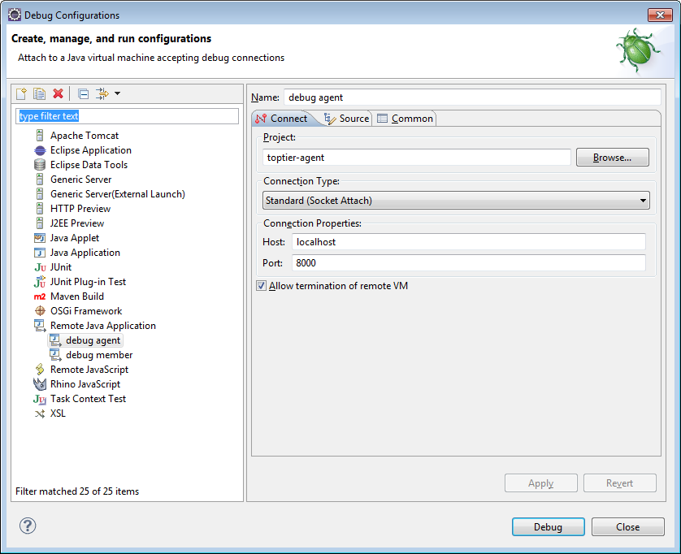

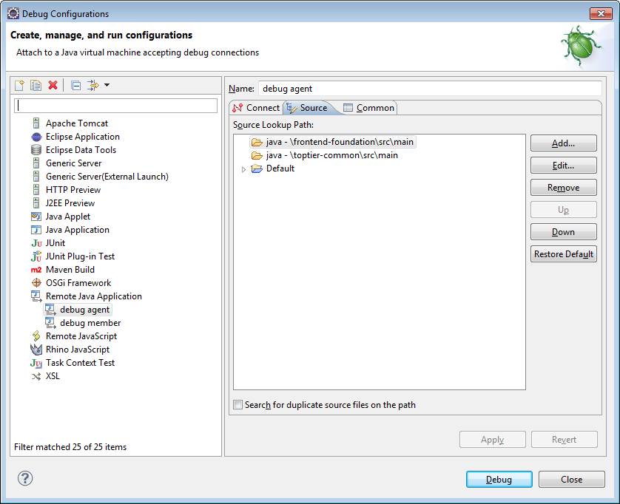

Setting Up Tomcat For Remote Debugging

<https://confluence.sakaiproject.org/display/BOOT/Setting+Up+Tomcat+For+Remote+Debugging>

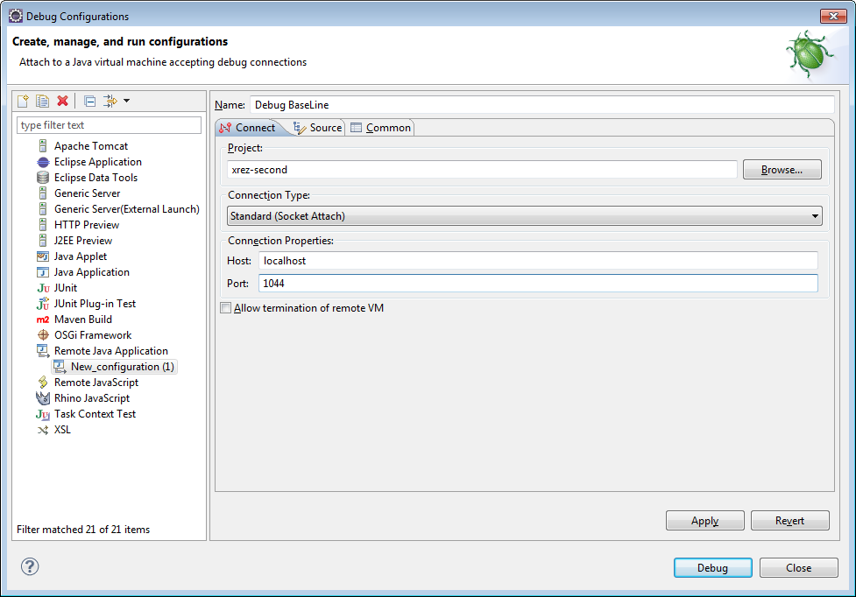

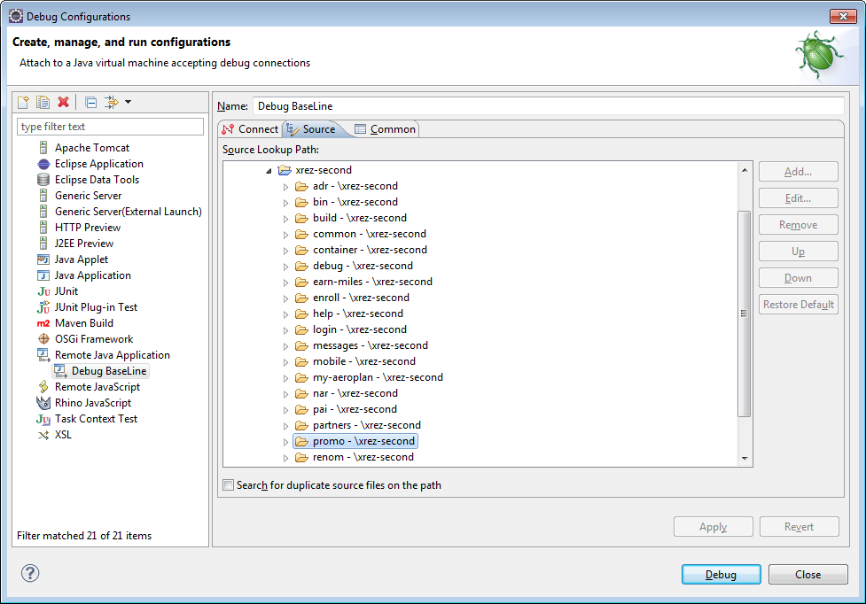

**3. eclipse advanced guide for debug**

<http://www.eclipse.org/resources/resource.php?id=405>

video

The Eclipse online help is also a good resource for information on running and debugging. See the following sections in the User's Guide (Help → Help Contents → Java Development User Guide):

* Concepts → Debugger
* Tasks → Running and debugging

Eclipse IDE Pocket Guide

**4. mockito tutorial**

http://gojko.net/2009/10/23/mockito-in-six-easy-examples/

**5. junit 4 tutorial eclipse**

<http://www.vogella.com/articles/JUnit/article.html>

**6. How to automatically generate comments for methods written by us in eclipse**

Ecrire au debut de la method “/**” suivi de retour .

**7. Change value live, for variables in Debugger**

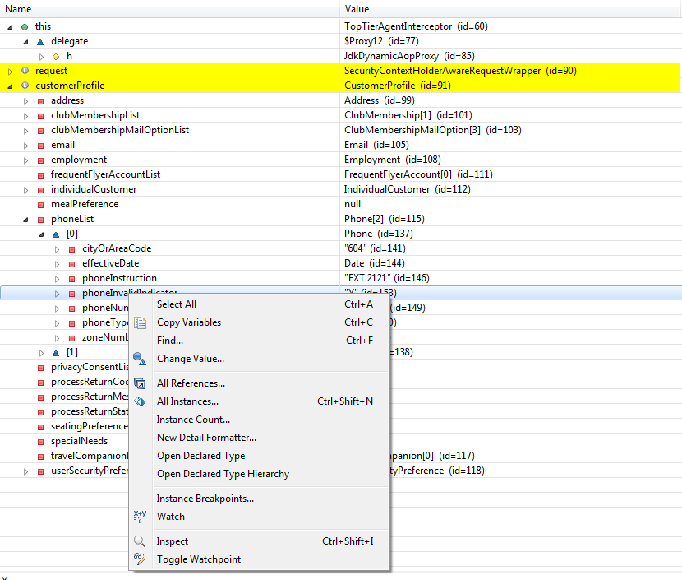

**8. howto display validation errors in freemarker template**

**9. 3rd party tools to search text in file**

<http://stackoverflow.com/questions/87350/what-are-good-grep-tool-for-windows>

<http://www.google.com.au/search?num=25&q=grep+tool+for+Windows>

grepWin

<http://tools.tortoisesvn.net/grepWin.html>

3rd party tools for Windows searching files for text strings

How To Search Any Content Or File Type In Multiple Locations Easily

File Searcher

<http://www.addictivetips.com/windows-tips/how-to-search-any-content-or-file-type-in-multiple-locations-easily/>

**10.** **Bloquer la date de Windows**

Desandre le service Windows Time

**11. Changer le character encoding pour un string**

String tst = “test no trois”);

byte[] b = tst.getBytes("ASCII");

String res = new String(b, "UTF-8");

How to convert Strings to and from UTF8 byte arrays in Java

<http://stackoverflow.com/questions/88838/how-to-convert-strings-to-and-from-utf8-byte-arrays-in-java>

Spring MVC messageSource spanish characters

<http://stackoverflow.com/questions/6535535/spring-mvc-messagesource-spanish-characters>

Avec Notpad++ on peut changer le encodage du fichier messages_fr.propreties

**12.** **How to get error text in controller from BindingResult**

<http://stackoverflow.com/questions/2751603/how-to-get-error-text-in-controller-from-bindingresult>

**13.** **Introduction to Spring Validation** (De citit)

<http://www.javabeat.net/articles/print.php?article_id=255>

<http://www.javabeat.net/category/spring/>

**14.** **Deserialize JSON with Jackson into Polymorphic Types** - A Complete Example

<http://programmerbruce.blogspot.ca/2011/05/deserialize-json-with-jackson-into.html>

**15.** **Effective Eclipse: Shortcut keys**

http://eclipse.dzone.com/news/effective-eclipse-shortcut-key

**16. Java's java.util.Calendar**

<http://tutorials.jenkov.com/java-date-time/java-util-calendar.html>

To subtract from the fields call the add() method with negative values, like this:

Calendar calendar = new GregorianCalendar();

calendar.add(Calendar.DAY_OF_MONTH, -1);

**17. Enlever le format pour des champs numériques dans des fichiers FTL**

recentActivities, recentActivitiesJson

<td class="statusMilesCol">${activity.statusMiles?c}</td>

<#import "/utils.ftl" as utils/>

{

"aaData": [

<#list activities as activity>

[

"<img src='/static/gfx/${utils.getRecentTransactionsImageName(activity)}'>",

"${utils.getMonthDayYear(activity.date, sessionLanguage)}",

"${activity.description?json_string}",

"${utils.getDefaultValue(activity.bookingClass, '-')?json_string}",

"${activity.statusMiles?c}",

"${utils.getYearMonth(activity.date)}",

"${activity.partner?json_string}"

]

<#if activity_has_next>,</#if>

</#list>

]

}

**18.** **Changer dynamiquement la valeur sélectionné dans un liste déroulante** id= « txSearchFrom ».

<script type="text/javascript">

$(document).ready(function() {

var currentTime = new Date();

console.log("year: "+currentTime.getFullYear()+" month: "+currentTime.getMonth()+('0'+(currentTime.getMonth()+1)).substr(-2,2));

var testValue = "";

testValue = currentTime.getFullYear()+""+currentTime.getMonth();

console.log("time: "+testValue);

var theValue = "201210"

$("#txSearchFrom").val( theValue ).attr('selected',true);

});

</script>

19. Keyboard shortcuts - Perform common Firefox tasks quickly

<http://support.mozilla.org/en-US/kb/keyboard-shortcuts-perform-firefox-tasks-quickly>

20. Converting Symbols, Accent Letters to English Alphabet

<http://stackoverflow.com/questions/1008802/converting-symbols-accent-letters-to-english-alphabet>

Class Pattern

http://docs.oracle.com/javase/1.5.0/docs/api/java/util/regex/Pattern.html

21. Advanced JavaScript Techniques You Should Know

<http://sixrevisions.com/javascript/6-advanced-javascript-techniques-you-should-know/>

22. How can I get Eclipse to show .* files?

<http://stackoverflow.com/questions/98610/how-can-i-get-eclipse-to-show-files>

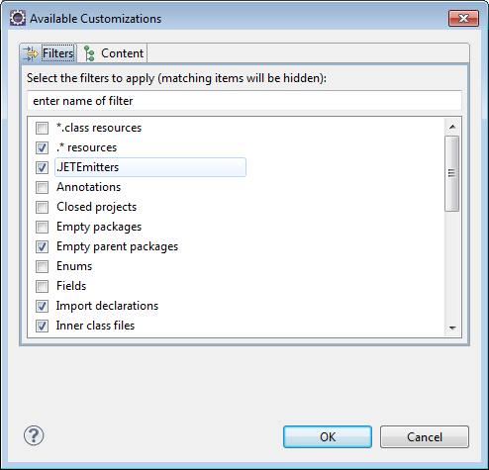

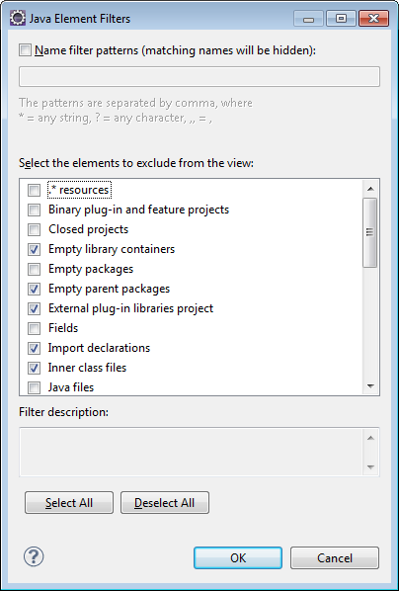

23. Notepad ++ mettre en commentaire un texte.

Mettre en sur briance le texte.

Click droite et choisir « Stream Comment ». Ou Toggle …

24. Configuration écrans

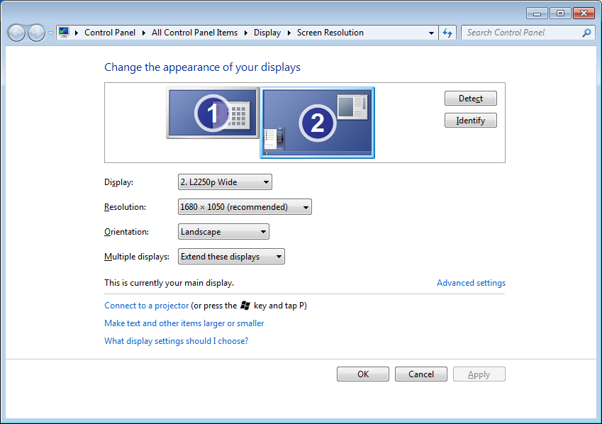

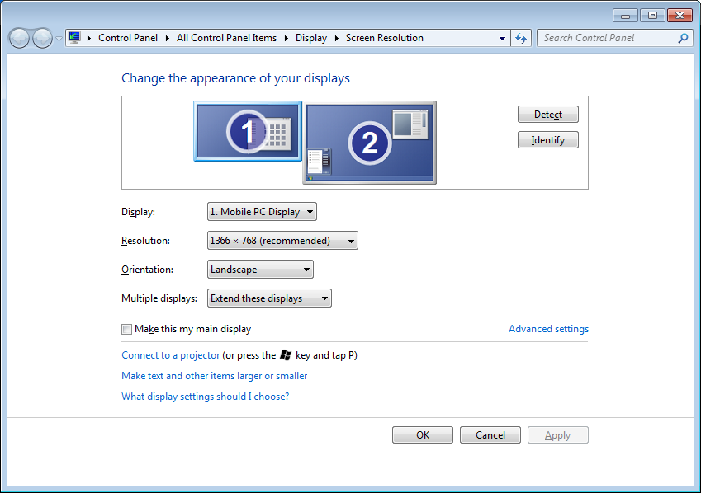

25. Erreur lors de l’accès par Wi-Fi

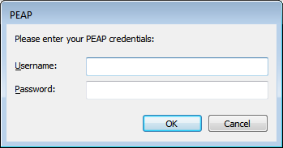

26. Pour accéder une session Linux via Putty, pour le site RT.

Lancer « Pageant » avec le mot de passe approprié de la clé « C:\MySpace\Projects\090 PentruMine\itrt_private.ppk ».

Quand je lanse Pageant il me donne le message.

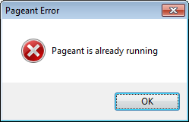

  Si je lance “itrt_private.ppk” il me demande.

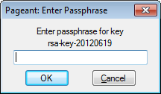

hellover1

rentre ca quand il te prompt avec le password

Lancer « Putty » avec la session « it-rt.aeroplan » et fournir seulement le nom d’utilisateur « itrt ».

Putty doit avoir la config :

socks 5

proxy : 172.28.128.13 : 1080

Voir :

C:\MySpace\Projects\090 PentruMine\099 Key\info.txt

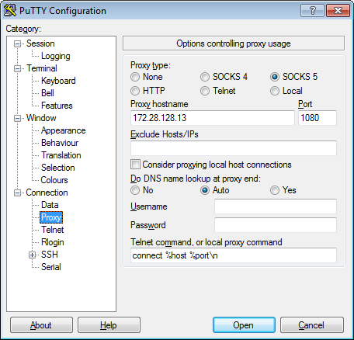

lancer

vim nom_fichier

27. **Setting up a spring mvc project with maven in eclipse**

<http://gkokkinos.wordpress.com/2012/01/02/setting-up-a-spring-mvc-project-with-maven-in-eclipse/>

28.

modern.IE.

<http://www.developpez.com/actu/51605/Microsoft-lance-modern-IE-un-ensemble-d-outils-gratuits-pour-tester-la-compatibilite-des-sites-Web/>

**29. For Junit coverage**

<http://update.eclemma.org/>

Snagit

Ctrl + Shift + R is not working in Eclipse

<http://stackoverflow.com/questions/5725587/ctrl-shift-r-is-not-working-in-eclipse>

If the conflict is with Snagit setting global hotkey, then change this in Snagit.

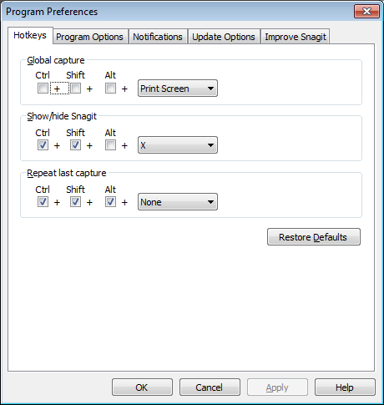

Tools>Program Preferences> Hotkeys and change default key combination to something else that doesn't conflict (e.g. just check Alt)

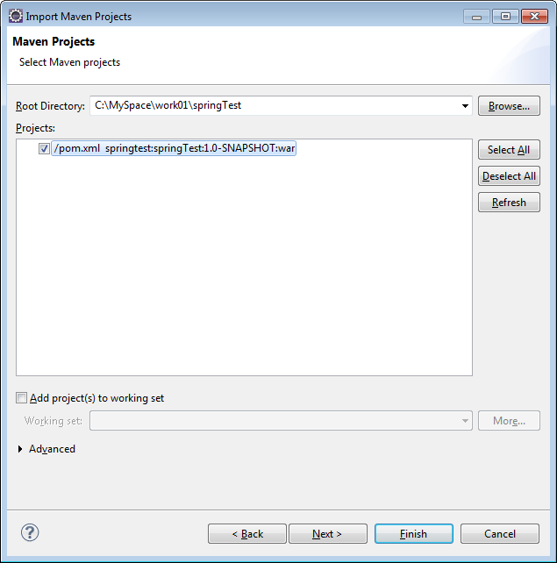

29. LeanKit!

30. Beyond compare

31. Le débogage en Java/Java EE

<http://aldian.developpez.com/cours/le-debogage-en-java-javaee/>

32. Highcharts - l’alignement au centre

textBBox = text.getBBox();

x = chart.plotLeft + (chart.plotWidth  * 0.5) - (textBBox.width  * 0.5);

33. Seter dans Eclipse

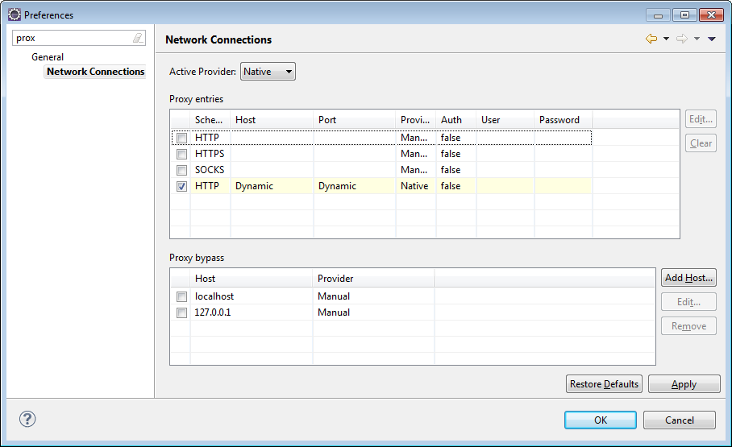

34. Configurer l’éditeur en ligne de commande DOS.

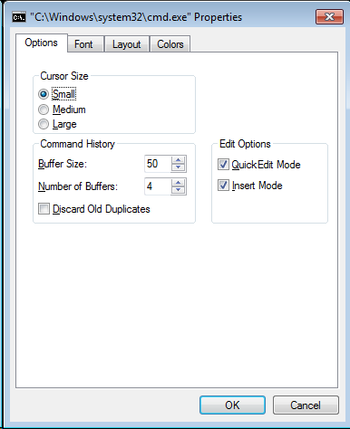

=================================================================================

De vazut, studiat

1. Interceptor (Spring)

2.

http://vviale.developpez.com/tutoriels/apprendre-a-taper/